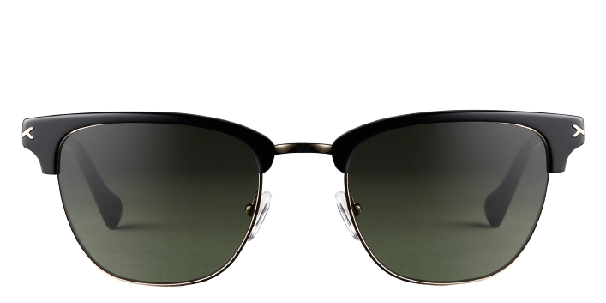 **Sirius Sun**

Product information

|  |  |
| --- | --- |
| **Brands** | Kits |
| **Gender** | Unisex |
| **Lenses** | Prescription lenses available |
| **Material** | Acetate |

Description

**If you love a good throwback, these Sirius clubmaster style sunglasses are for you. The KITS logo is engraved on the inside of the bridge bar for a subtle nod. The classic tortoiseshell pairs perfectly with the shiny silver. Spring hinges and adjustable nose pads give these sunglasses a customized feel. Please note these frames fit large and are best suited to those with wider faces**

|  |
| --- |
| What You’ll Get   * **Optical grade sun lenses with 100% UV protection.** * **Soft case and cleaning cloth.** * **Unconditional 30 days return policy. Free return shipping.** |